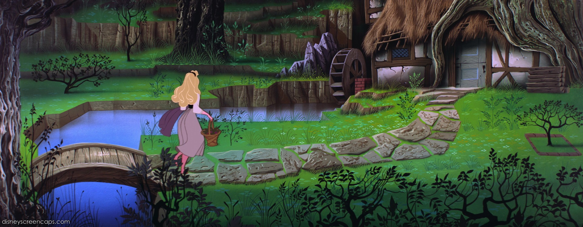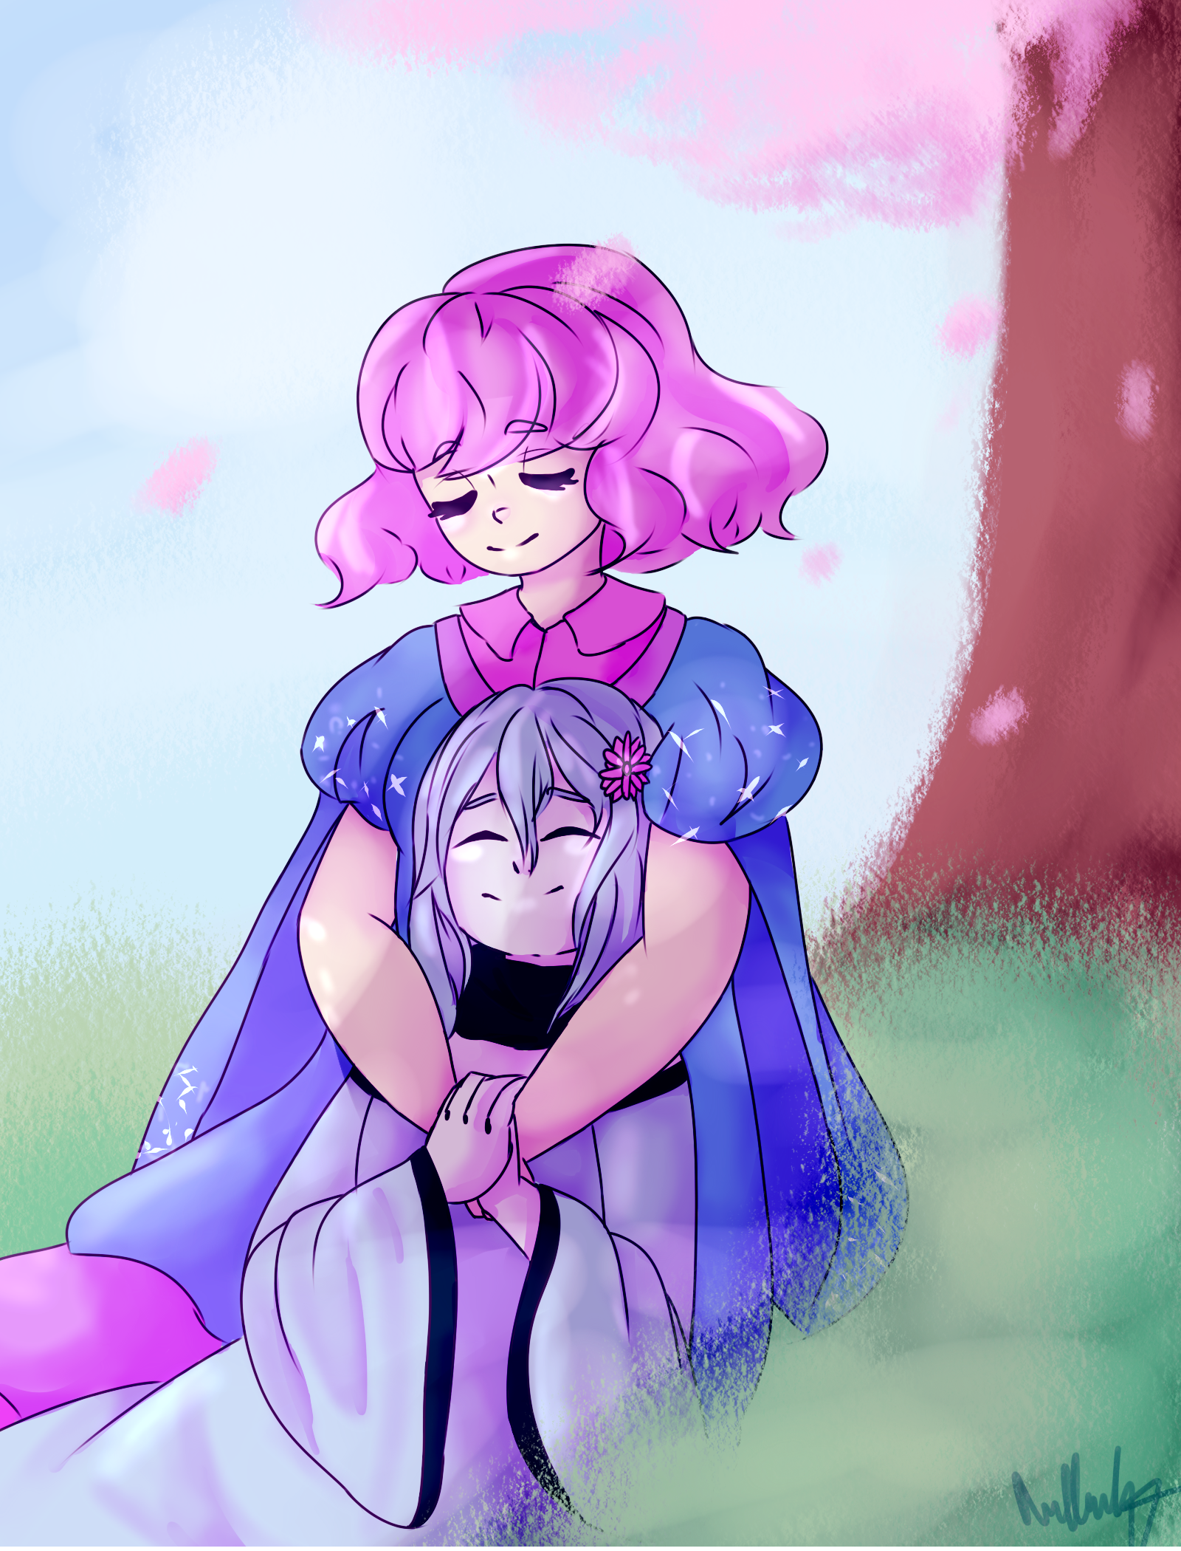

**ERA 1 - the cottagecore/fairycore lookin ass origin story**

* the planet had been around for quite some time, but the societies on asilles at this time were probably equivalent to maybe earth’s 1700-1800s? in terms of advancement. but, no technology or probably even industrialization yet
* plus the added fantasy/woodsy elements like fae. sleeping beauty vibes but if it took place in the early 1800s/late 1700s.

**Major Events in this Era:**

1. esela is born, grows up with her grandmother in her small clan/village?
2. **+ ~ 20-30 years** esela meets kulith and they have their daughter
3. **+ < 10 years** meteorite hits crescentmoon, sending debris flying into asilles. the impact of the debris caused the destruction of a large portion of the planet, and the population is cut to roughly 100 million.
4. esela and kulith’s daughter dies.
5. esela decides to make the moons habitable using her magic.



**ERA 2 - life on the asilles moons**

* a kind of transitionary period between stable societies.
* population on asilles at this point is brought down to a couple million after esela brings everyone up.

**Major Events in this Era:**

1. merisdae is created to oversee the moons, cecil is created to make and maintain the ocean on crescentmoon, and whimsey and sprinkles are created to protect the moons from more asteroids.
2. kulith uses their astral projecting powers to gather people from asilles to move up to the moons, and esela uses their transporting powers to actually take them.
3. **+ (some time)** esela’s powers begin to diminish, leaving kulith stranded on asilles since they were still down there gathering people.
4. **[**[**bloodmoon arc**](https://docs.google.com/document/d/1zQlTvHgEEKldbMIvHCq-SNDd2uWxG2hXoKSUwEAi_B4/edit?usp=sharing)**]** bloodmoon gets salty about being in charge of criminals and kidnaps esela. drama ensues